

实 验 报 告

课程名称： | 信息系统安全
学生姓名： | 郑宜静
学生学号： | 201630666516
学生专业： | 软件工程
开课学期： | 2018-2019学年下学期

软件学院
2019年4月

DES加解密算法编程实现

一 程序代码
#include<iostream>
#include<ctime>
#include<fstream>

#define PLAIN_FILE_OPEN_ERROR -1
#define KEY_FILE_OPEN_ERROR -2
#define CIPHER_FILE_OPEN_ERROR -3
#define OK 1

using namespace std;

// 初始置换表
int IP_Table[64] = {
58,50,42,34,26,18,10,2,
60,52,44,36,28,20,12,4,
62,54,46,38,30,22,14,6,
64,56,48,40,32,24,16,8,
57,49,41,33,25,17,9,1,
59,51,43,35,27,19,11,3,
61,53,45,37,29,21,13,5,
63,55,47,39,31,23,15,7
};
// 逆初始置换表
int IP_1_Table[64] = {
40,8,48,16,56,24,64,32,
39,7,47,15,55,23,63,31,
38,6,46,14,54,22,62,30,
37,5,45,13,53,21,61,29,
36,4,44,12,52,20,60,28,
35,3,43,11,51,19,59,27,
34,2,42,10,50,18,58,26,
33,1,41,9,49,17,57,25
};

int S_Box[8][4][16] = {
{
{14,4,13,1,2,15,11,8,3,10,6,12,5,9,0,7},
{0,15,7,4,14,2,13,1,10,6,12,11,9,5,3,8},
{4,1,14,8,13,6,2,11,15,12,9,7,3,10,5,0},
{15,12,8,2,4,9,1,7,5,11,3,14,10,0,6,13}
},
{
{15,1,8,14,6,11,3,4,9,7,2,13,12,0,5,10},
{3,13,4,7,15,2,8,14,12,0,1,10,6,9,11,5},
{0,14,7,11,10,4,13,1,5,8,12,6,9,3,2,15},
{13,8,10,1,3,15,4,2,11,6,7,12,0,5,14,9}
},
{
{10,0,9,14,6,3,15,5,1,13,12,7,11,4,2,8},
{13,7,0,9,3,4,6,10,2,8,5,14,12,11,15,1},
{13,6,4,9,8,15,3,0,11,1,2,12,5,10,14,7},
{1,10,13,0,6,9,8,7,4,15,14,3,11,5,2,12}
},
{
{7,13,14,3,0,6,9,10,1,2,8,5,11,12,4,15},
{13,8,11,5,6,15,0,3,4,7,2,12,1,10,14,9},
{10,6,9,0,12,11,7,13,15,1,3,14,5,2,8,4},
{3,15,0,6,10,1,13,8,9,4,5,11,12,7,2,14}
},
{
{2,12,4,1,7,10,11,6,5,8,3,15,13,0,14,9},
{14,11,2,12,4,7,13,1,5,0,15,13,3,9,8,6},
{4,2,1,11,10,13,7,8,15,9,12,5,6,3,0,14},
{11,8,12,7,1,14,2,13,6,15,0,9,10,4,5,3}
},
{
{12,1,10,15,9,2,6,8,0,13,3,4,14,7,5,11},
{10,15,4,2,7,12,9,5,6,1,13,14,0,11,3,8},
{9,14,15,5,2,8,12,3,7,0,4,10,1,13,11,6},
{4,3,2,12,9,5,15,10,11,14,1,7,6,0,8,13}
},
{
{4,11,2,14,15,0,8,13,3,12,9,7,5,10,6,1},
{13,0,11,7,4,9,1,10,14,3,5,12,2,15,8,6},
{1,4,11,13,12,3,7,14,10,15,6,8,0,5,9,2},
{6,11,13,8,1,4,10,7,9,5,0,15,14,2,3,12}
},
{
{13,2,8,4,6,15,11,1,10,9,3,14,5,0,12,7},
{1,15,13,8,10,3,7,4,12,5,6,11,0,14,9,2},
{7,11,4,1,9,12,14,2,0,6,10,13,15,3,5,8},
{2,1,14,7,4,10,8,13,15,12,9,0,3,5,6,11}
}
};

//置换选择1
int PC_1[56] =
{
57, 49, 41, 33, 25, 17, 9,1, 58, 50, 42, 34, 26, 18,
10, 2, 59, 51, 43, 35, 27,19, 11, 3, 60, 52, 44, 36,
63, 55, 47, 39, 31, 23, 15,7, 62, 54, 46, 38, 30, 22,
14, 6, 61, 53, 45, 37, 29,21, 13, 5, 28, 20, 12, 4
};

//扩充置换表E
int E_Table[8][2] = {
{32,5},{4,9},{8,13},{12,17},{16,21},{20,25},{24,29},{28,1}
};

//置换选择2
int PC_2[48] =
{
14, 17, 11, 24, 1, 5, 3, 28, 15, 6, 21, 10,
23, 19, 12, 4, 26, 8, 16, 7, 27, 20, 13, 2,
41, 52, 31, 37, 47, 55,30, 40, 51, 45, 33, 48,
44, 49, 39, 56, 34, 53,46, 42, 50, 36, 29, 32
};//密钥压缩表

//置换函数P
int P_Table[32] =
{
16, 7, 20, 21, 29, 12, 28, 17,1, 15, 23, 26,5, 18, 31, 10,
2, 8, 24, 14, 32, 27, 3, 9, 19,13, 30, 6, 22,11, 4, 25
};//p盒置换表

// 左移位数表
int iteration_movement[16] = { 1,1,2,2,2,2,2,2,1,2,2,2,2,2,2,1 };

//密钥置换
void DES_PC1_Transform(char key[64], char temp[56]) {
for (size_t i = 0; i < 56; i++)
{
temp[i] = key[PC_1[i] - 1];
}
}

void DES_PC2_Transform(char key[56], char temp[48]) {
for (size_t i = 0; i < 48; i++)
{
temp[i] = key[PC_2[i] - 1];
}
}

// 循环左移
void DES_ROL(char data[56], int time) {
char temp[56];

//保存将要循环移动到右边的位
memcpy(temp, data, time);
memcpy(temp + time, data + 28, time);

//前28位移动
memcpy(data, data + time, 28 - time);
memcpy(data + 28 - time, temp, time);

//后28位移动
memcpy(data + 28, data + 28 + time, 28 - time);
memcpy(data + 56 - time, temp + time, time);

}

//生成子密钥
void DES_MakeSubKeys(char key[64], char subKeys[16][48]) {
char temp[56];
DES_PC1_Transform(key, temp);//PC1置换
for (int cnt = 0; cnt < 16; cnt++) {//16轮跌代，产生16个子密钥
DES_ROL(temp, iteration_movement[cnt]);//循环左移
DES_PC2_Transform(temp, subKeys[cnt]);//PC2置换，产生子密钥
}
}

//IP置换
void DES_IP_Transform(char data[64]) {
char temp[64];
for (int cnt = 0; cnt < 64; cnt++) {
temp[cnt] = data[IP_Table[cnt] - 1];
}
memcpy(data, temp, 64);
}

//IP逆置换
void DES_IP_1_Transform(char data[64]) {
char temp[64];
for (int cnt = 0; cnt < 64; cnt++) {
temp[cnt] = data[IP_1_Table[cnt] - 1];
}
memcpy(data, temp, 64);
}

//扩展置换
void DES_E_Transform(char data[48]) {
char temp[48];
for (size_t i = 0; i < 8; i++)
{
temp[i * 6] = E_Table[i][0];
temp[i * 6 + 5] = E_Table[i][1];
temp[i * 6 + 1] = data[i * 4];
temp[i * 6 + 2] = data[i * 4 + 1];
temp[i * 6 + 3] = data[i * 4 + 2];
temp[i * 6 + 4] = data[i * 4 + 3];
}
memcpy(data, temp, 48);
}

//P置换
void DES_P_Transform(char data[32]) {
char temp[32];
for (int cnt = 0; cnt < 32; cnt++) {
temp[cnt] = data[P_Table[cnt] - 1];
}
memcpy(data, temp, 32);
}

//异或
void DES_XOR(char R[48], char L[48], int count) {
for (int cnt = 0; cnt < count; cnt++) {
R[cnt] ^= L[cnt];
}
}

//S盒置换
void DES_SBOX(char data[48]) {
int line, row, output;
int cur1, cur2;
for (int cnt = 0; cnt < 8; cnt++) {
cur1 = cnt * 6;
cur2 = cnt << 2;

//计算在S盒中的行与列
line = (data[cur1] << 1) + data[cur1 + 5];//每组第一位乘2加上第六位
row = (data[cur1 + 1] << 3) + (data[cur1 + 2] << 2)
+ (data[cur1 + 3] << 1) + data[cur1 + 4];//每组第二位乘8加上第三位乘4加上第四位乘2加上第五位
output = S_Box[cnt][line][row];

//化为2进制
data[cur2] = (output & 0X08) >> 3;
data[cur2 + 1] = (output & 0X04) >> 2;
data[cur2 + 2] = (output & 0X02) >> 1;
data[cur2 + 3] = output & 0x01;
}
}

//交换
void DES_Swap(char left[32], char right[32]) {
char temp[32];
memcpy(temp, left, 32);
memcpy(left, right, 32);
memcpy(right, temp, 32);
}

//加密单个分组
void DES_EncryptBlock(char plainBlock[64], char subKeys[16][48]) {
char copyRight[48];
int cnt;

//初始置换（IP置换）
DES_IP_Transform(plainBlock);
//16轮迭代
for (cnt = 0; cnt < 16; cnt++) {
memcpy(copyRight, plainBlock + 32, 32);
//将右半部分进行扩展置换，从32位扩展到48位
DES_E_Transform(copyRight);
//将右半部分与子密钥进行异或操作
DES_XOR(copyRight, subKeys[cnt], 48);
//异或结果进入S盒，输出32位结果
DES_SBOX(copyRight);
//P置换
DES_P_Transform(copyRight);
//将明文左半部分与右半部分进行异或
DES_XOR(plainBlock, copyRight, 32);
if (cnt != 15) {
//最终完成左右部的交换
DES_Swap(plainBlock, plainBlock + 32);
}
}
//逆初始置换（IP^1置换）
DES_IP_1_Transform(plainBlock);
}

//解密单个分组
void DES_DecryptBlock(char cipherBlock[64], char subKeys[16][48]) {
char copyRight[48];

//初始置换（IP置换）
DES_IP_Transform(cipherBlock);

//16轮迭代
for (int cnt = 15; cnt >= 0; cnt--) {
memcpy(copyRight, cipherBlock + 32, 32);
//将右半部分进行扩展置换，从32位扩展到48位
DES_E_Transform(copyRight);
//将右半部分与子密钥进行异或操作
DES_XOR(copyRight, subKeys[cnt], 48);
//异或结果进入S盒，输出32位结果
DES_SBOX(copyRight);
//P置换
DES_P_Transform(copyRight);
//将明文左半部分与右半部分进行异或
DES_XOR(cipherBlock, copyRight, 32);
if (cnt != 0) {
//最终完成左右部的交换
DES_Swap(cipherBlock, cipherBlock + 32);
}
}
//逆初始置换（IP^1置换）
DES_IP_1_Transform(cipherBlock);
}

//加密文件
int DES_Encrypt(const char *plainFileName, const char *keyFileName, const char *cipherFileName) {
char plainBlock[65], cipherBlock[64], keyBlock[65];
char subKeys[16][48];
ifstream plainFile(plainFileName);
ifstream keyFile(keyFileName);
ofstream cipherFile(cipherFileName);
if (plainFile.is_open()) {
plainFile.getline(plainBlock, 65);
cout << "明文：" << plainBlock << endl;
plainFile.close();
}
else
{
return PLAIN_FILE_OPEN_ERROR;
}
//处理明文读取出错
if (keyFile.is_open()) {
//设置密钥
keyFile.getline(keyBlock, 65);
cout << "密钥：" << keyBlock << endl;
keyFile.close();
}
else {
return KEY_FILE_OPEN_ERROR;
}
//处理密钥文件读取出错
if (!cipherFile.is_open()) {
return CIPHER_FILE_OPEN_ERROR;
}

//生成子密钥
DES_MakeSubKeys(keyBlock, subKeys);

DES_EncryptBlock(plainBlock, subKeys);//加密
cout << "密文：" << plainBlock << endl;
//保存
cipherFile << plainBlock;
cipherFile.close();
return OK;
}
int DES_Decrypt(const char *cipherFileName, const char *keyFileName, const char *plainFileName) {
char plainBlock[65], cipherBlock[65], keyBlock[65];
ofstream plainFile(plainFileName);
ifstream keyFile(keyFileName);
ifstream cipherFile(cipherFileName);
if (cipherFile.is_open()) {
cipherFile.getline(cipherBlock, 65);
cout << "密文：" << cipherBlock << endl;
cipherFile.close();
}
else
{
return CIPHER_FILE_OPEN_ERROR;
}
//处理密文读取出错
if (keyFile.is_open()) {
//设置密钥
keyFile.getline(keyBlock, 65);
cout << "密钥：" << keyBlock << endl;
keyFile.close();
}
else {
return KEY_FILE_OPEN_ERROR;
}
//处理明文文件读取出错
if (!plainFile.is_open()) {
return PLAIN_FILE_OPEN_ERROR;
}

//生成子密钥
char subKeys[16][48];
DES_MakeSubKeys(keyBlock, subKeys);

DES_DecryptBlock(cipherBlock, subKeys);
cout << "明文：" << cipherBlock << endl;
//保存
plainFile << cipherBlock;
plainFile.close();
return OK;
}

int main()
{
int result;
clock_t a, b;
a = clock();
result = DES_Encrypt("src.txt", "src2.txt", "target1.txt");//加密并返回结果
if (result == -1)
{
printf("找不到明文文件或者读取出错\n");
return 0;
}
if (result == -2)
{
printf("找不到密钥文件或者读取出错\n");
return 0;
}
b = clock();
cout << "加密消耗" << b - a << "毫秒\n";

system("pause");
a = clock();
DES_Decrypt("target1.txt", "src2.txt", "target2.txt");
b = clock();
cout << "解密消耗" << b - a << "毫秒\n";
system("pause");
return 0;
}

二 执行结果

使用同一密钥，对两组明文进行加密和解密。
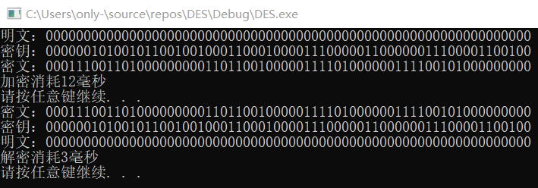
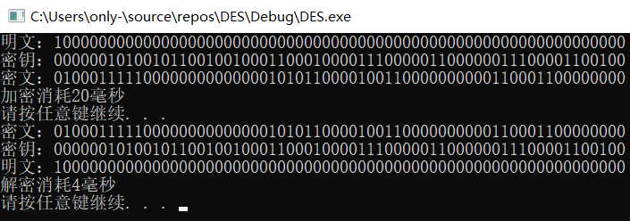
密文1：00011100 11010000 00000110 11001000 00111101 00000011 11001010 00000000
密文2：01000111 11000000 00000000 10101100 00100110 00000000 01100011 00000000
两个密文块间不同数据位的数量：21

对同一段明文，使用不同密钥进行加密和解密操作。
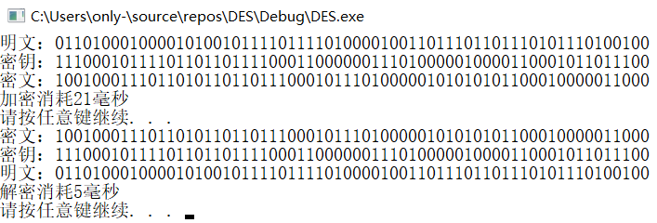
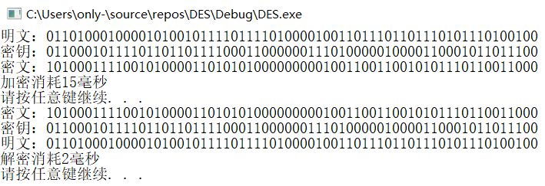
密文1：10010001 11011010 11011011 10001011 10100000 10101010 11000100 00011000
密文2：10100011 11001010 00011010 10100000 00001001 10011001 01011101 10011000
两个密文块间不同数据位的数量：24

三 实验思考
在密码学中，雪崩效应（Avalanche effect）指加密算法（尤其是块密码和加密散列函数）的一种理想属性。雪崩效应是指当输入发生最微小的改变（例如，反转一个二进制位）时，也会导致输出的剧变（如，输出中一半的二进制位发生反转）。
严格雪崩准则（Strict Avalanche Criterion，SAC）是雪崩效应的形式化。它指出，当任何一个输入位被反转时，输出中的每一位均有50%的概率发生变化。

根据我的实验结果，我认为DES加密算法不具有雪崩效应。

